**Linux Commands**

**1.man command:** man, command in Linux is used to display the user manual of any command that we can run on the terminal.

Syntax: man [option] [command]

Example:

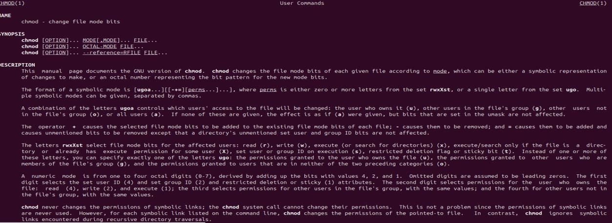

**2. whatis command:** whatis, command in Linux is used to get a one-line manual page description. In Linux, each manual page has some sort of description within it.

Syntax: whatis [option] [command_name]

Example:

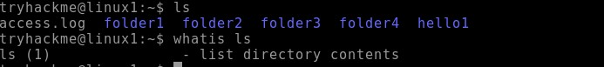

**3. Is command:** Is is a Linux shell command that lists directory contents of files and directories. It provides valuable information about files, directories, and their attributes.

Syntax: Is [option] [file/directory]

Example:

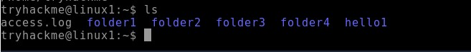

**4. cd command:** Linux cd command is used to change the current working directory (i.e., in which the current user is working). The "cd" stands for 'change directory.

Syntax: cd <dirname>

Example:

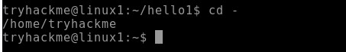

**5. mkdir command:** The mkdir stands for 'make directory'. With the help of mkdir command, you can create a new directory wherever you want in your system.

Syntax: mkdir <dirname>

Example:



**6. rmdir command:** This command is used to delete a directory. But will not be able to delete a directory including a sub-directory. It means, a directory has to be empty to be deleted.

Syntax: rmdir <dirname>

Example:

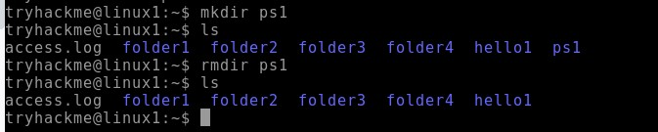

**7. date command:** date command is used to display the system date and time. date command is also used to set date and time of the system.

Syntax: date [OPTION]... [+FORMAT]

Example:



**8. wd command:** PWD stands for Print Working Directory. It writes the complete path name of the working directory to standard output.

Syntax: pwd [-options]

Example:

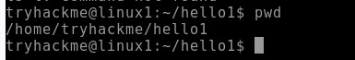

**9. whoami command:** Find out what user we're currently logged in as!

Syntax: whoami [OPTION]

Example:

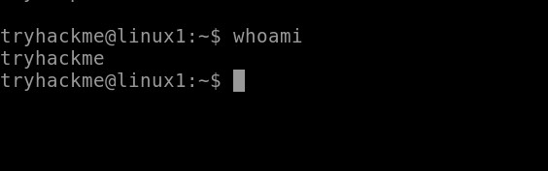

**10. su command:** The su command in Linux lets you switch to another user's account or execute commands as a different user.

Syntax: su [options] [username]

Example:

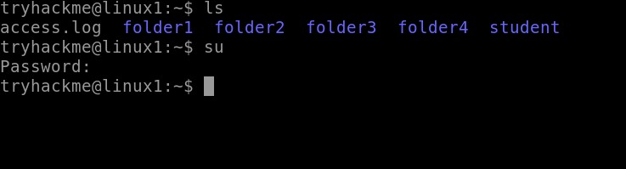

**11. sudo command:** The sudo command temporarily elevates privileges, allowing users to complete sensitive tasks without logging in as the root user.

Syntax: sudo [command]

Example:

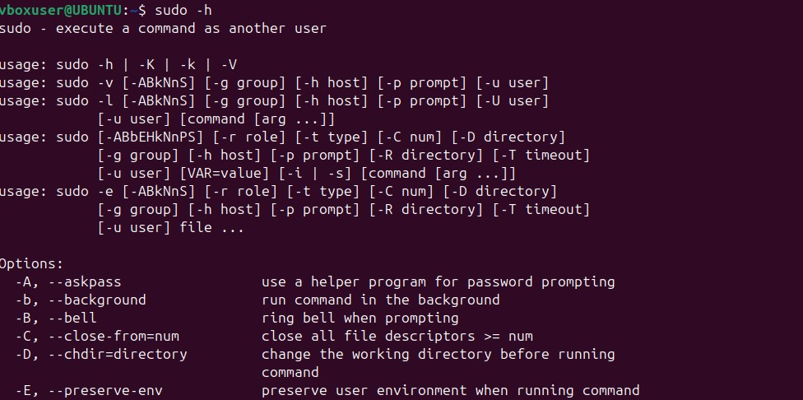

**12.ls-l command:** lists files and directories in long format, providing detailed information about each item.

Syntax:ls -I [OPTION] [FILE...]

Example:

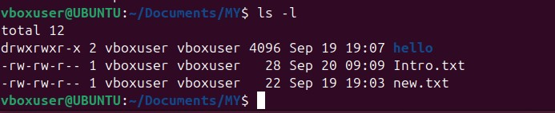

**13.ls-a command:** lists all files and directories, including hidden ones. Hidden files and directories in Linux start with a dot (.).

Syntax:ls -a [OPTION] [FILE...]

Example:

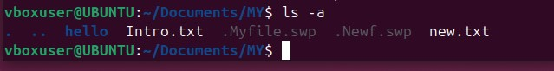

**14.cat command:** is used to concatenate and display the content of files. It stands for "concatenate" and is a simple but versatile command.

Syntax: cat [OPTION] [FILE...]

Example:



**15.cat>command:** is used to create a new file and input text into it directly from the command line. The > symbol redirects the output from the cat command into a new file, effectively creating the file and allowing you to enter its content interactively.

Syntax: cat > filename

Example:

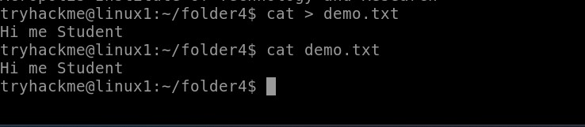

**16.kill command:** The kill command in Linux (located in /bin/kill), is a built-in command which is used to terminate processes manually

# Syntax: kill [signal] PID

Example:

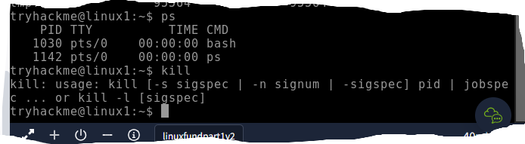

**17.cp command:** The cp command in Linux is used to copy files and directories

Syntax:cp [options] source destination

Example:

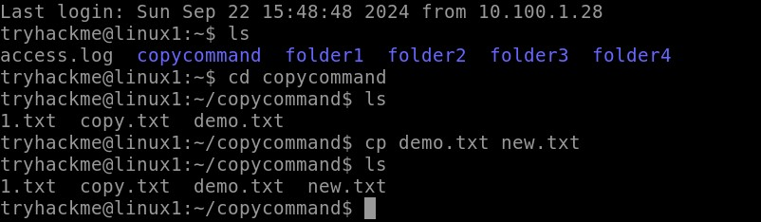

**18.mv command:** The mv command in Linux is used to move or rename files and directories

Syntax: mv [options] source destination

Example:

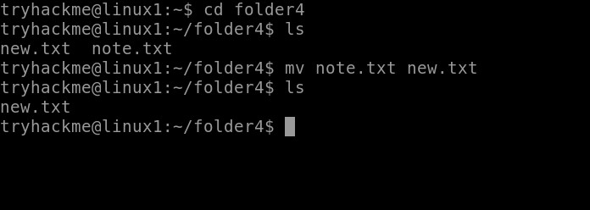

**19.grep command:** The grep command in Linux is a powerful utility used to search for specific patterns within files or input data.

Syntax: grep [options] pattern [file...]

Example:

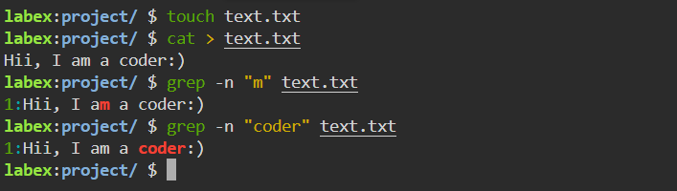

**20.touch command:** The touch command in Linux is used to create empty files or update the timestamps of existing files.

Syntax: touch [options] file...

Example:

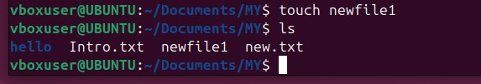

**21.Echo Command:** [echo command](https://www.geeksforgeeks.org/echo-command-in-linux-with-examples/) in Linux is specially used to print something in the terminal .

Syntax: echo <Text>

Example:



**22.df command:** The df (disk free) command in Linux is used to display information about the available disk space on your file systems.

Syntax: df [options] [file...]

Example:

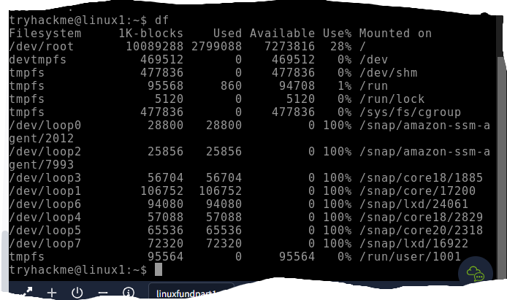

**23.passwd command:** is used to change a user's password. It can be used by users to change their own passwords or by administrators to change passwords for other users.

Syntax: passwd [options] [username]

Example:

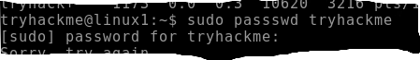

**24.head command:** The head command in Linux is used to display the beginning of a file or stream of data.

Syntax: head [options] [file...]

Example:

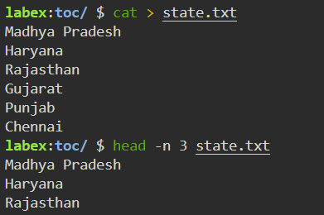

**25.tail command:** The tail command in Linux is used to display the end of a file or data stream.

Syntax: tail (options) [file...]

Example:

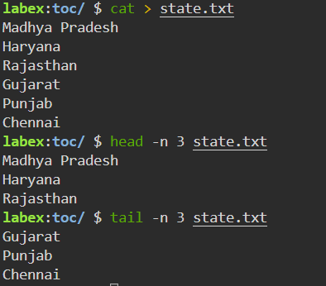

**26.find command:** The find command in Linux is a powerful utility used for searching files and directories within a directory hierarchy based on various criteria

Syntax: find [path] [expressio]

Example:

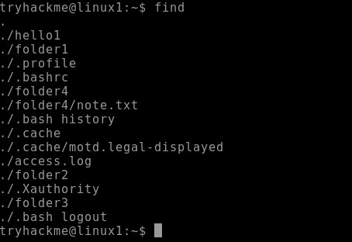

**27.ps command:** The ps command in Linux is used to display information about running processes.

Syntax: ps [options]

Example:

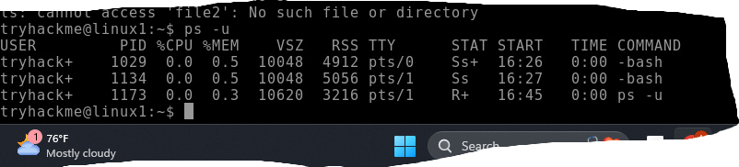

**28.pwd command:** The pwd command in Linux stands for "print working directory." It is used to display the current working directory of the user.

Syntax: pwd [options]

Example:



**29. cal command:** The [cal command](https://www.geeksforgeeks.org/cal-command-in-linux-with-examples/) is not the most famous command in the terminal but it functions to view the calendar for a particular month in the terminal. Let’s see how this works.

Syntax: cal<month><year>

Example:

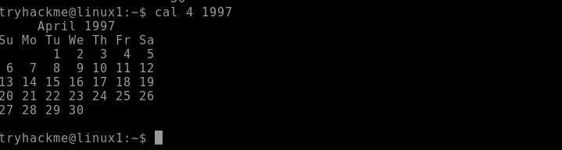

**30. uid command:** The id command displays the user ID (UID)

Syntax: id-u $(whoami)

Example:

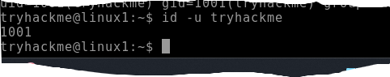

**31. gid command:** The id command displays the user ID (UID) and group ID (GID) information for the current user or a specified user.

Syntax: id username

Example:

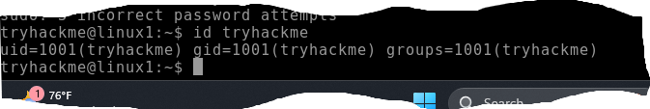

**32. wc command:** wc command in Linux stands for "word count" and is used to count lines, words, and characters in files. It can be a handy tool for getting quick statistics about file content.

Syntax: wc [options] [file...]

Example:

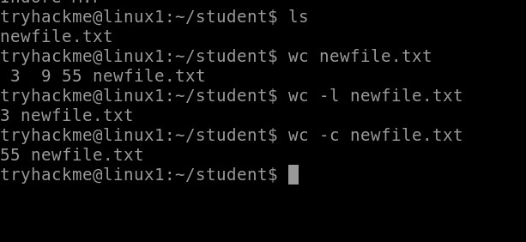

**33. du command:** The more command in Linux is a pager utility used to view the contents of files or command output one page at a time.

Syntax: more [OPTION] [FILE...]

Example:

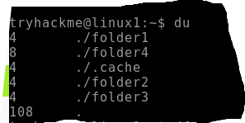

**34. less command:** The less command in Linux is a pager program used for viewing the contents of files or command output one screen at a time.

Syntax: less [OPTION] [FILE...]

Example:



**35. chown command:** The chown command in Linux is used to change the ownership of files and directories.

Syntax: chown [OPTION] USER[:GROUP] FILE...

Example:

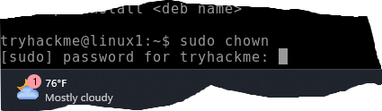

36. ipconfig command: The ipconfig command is used in Windows to display and manage the network configuration of your system. However, in Linux, the equivalent command is typically ifconfig or ip.

Syntax: ipconfig [OPTION]

Example:

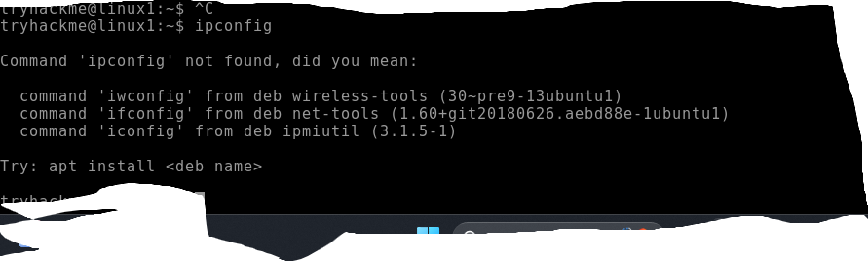

37. ifconfig command: The ifconfig command in Linux is used to configure and display network interface parameters for the operating system.

Syntax: ifconfig [INTERFACE] [OPTIONS]

Example:

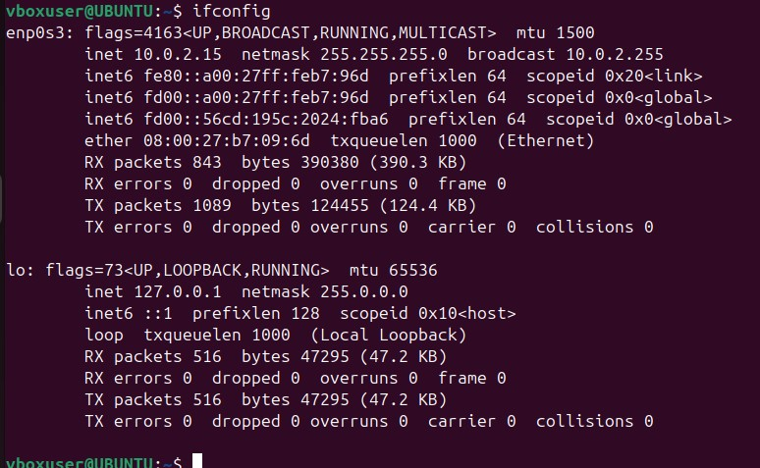

**38. ln command:**The ln command in Linux is used to create links between files. There are two types of links: hard links and symbolic (soft) links.

Syntax: ln [options] target [link_name]

Example:

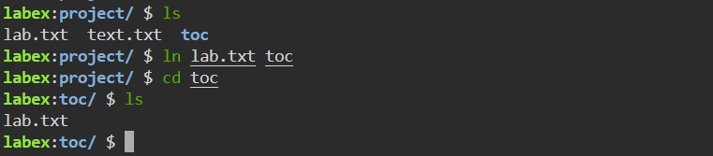

**39. rm command:** The rm command deletes files from a directory.

Syntax: rm [options) file1 file2

Example:

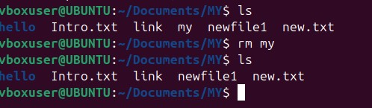

**40. whatis command:** The whatis command in Linux is used to display a brief description of a command or a system call. It provides a quick way to get an overview of what a command does, based on its man page.

Syntax: whatis [OPTION]... COMMAND...

Example:

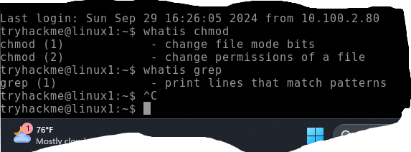

**41. pid command:** The pid command itself doesn't exist as a standalone command in Linux, but "PID" refers to the Process ID, which is a unique identifier assigned by the operating system to each running process. To work with PIDs, you typically use other commands like ps, top, kill, and pgrep.

Example:

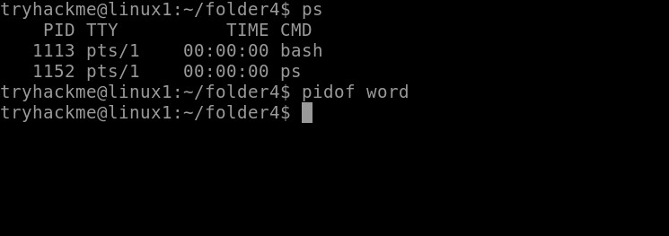

**42. chmod command:** The chmod command in Linux is used to change the file mode bits (permissions) of a file or directory. It controls who can read, write, or execute the file.

Syntax: chmod [OPTION]... MODE FILE...

Example:

